LESSON 18.
Microbiology diagnosis of viral hepatitis
LESSON PLAN:
• Hepatitis viruses, classification
- Hepatitis A virus. Characteristics of the virion. Resistance, ways of infection, pathogenesis. Microbiological diagnosis. Specific prevention.
- Hepatitis B virus. Virion structure, antigens, persistence, ways of infection. Pathogenesis of the disease. Immunity. Microbiological diagnosis. Specific prevention.
- Hepatitis D virus. Structure of the virion, pathogenetic features of the disease
- Hepatitis C virus, characteristics, genotypes, ways of infection, pathogenesis. Microbiological diagnosis. Specific prevention problem.
- Hepatitis E virus. Virion structural features, genome, antigens, cultivation, persistence, ways of infection. Pathogenesis, clinic, complications of the disease (during pregnancy). Microbiological diagnosis, specific prevention
- Hepatitis G virus. Virion structural features, epidemiology, role in human pathology. Microbiological diagnosis.

HEPATITIS VIRUSES
Trigger Words
Hepatitis A: acute/sudden onset, picornavirus, fecal-oral
Hepatitis B: blood-borne, STD, hepadnavirus, reverse transcriptase, chronic, Dane particle, HBsAg
Hepatitis C: chronic, blood-borne, flavivirus
Hepatitis D: defective, hepatitis B helper virus, fulminant disease
Hepatitis E: fecal-oral, acute/sudden onset, pregnant women

Biology, Virulence, and Disease
ᑏᑏ Liver disease defines symptoms
ᑏᑏNonlytic viruses: cell-mediated immunity causes symptoms
ᑏᑏHepatitis A: nonlytic picornavirus, acute onset, no sequelae
ᑏᑏHepatitis B: hepadnavirus, enveloped and encodes reverse transcriptase
ᑏᑏDisease followed by serology
ᑏᑏChronic disease 5% of time, especially in children
ᑏᑏ Risk for PHC
ᑏᑏHepatitis C: flavivirus
ᑏᑏCauses chronic disease in 70% of patients
ᑏᑏ Risk for PHC and cirrhosis after long period
ᑏᑏHepatitis D: viroid-like, requires HBV as helper virus
ᑏᑏHepatitis E: Hepevirus, calici-like virus, acute onset, no sequelae, severe for pregnant women

Epidemiology
ᑏᑏHAV, HEV: fecal-oral transmission
ᑏᑏHBV, HCV, HDV: spread in blood, tissue, and semen; STDs

Diagnosis
ᑏᑏ RT-PCR, ELISA

Treatment, Prevention, and Control
ᑏᑏHAV: inactivated vaccine, hygiene
ᑏᑏHEV: hygiene
ᑏᑏHBV: virus-like particle HBsAg vaccine, screening of blood supply, safe sex, antiviral drugs
ᑏᑏHCV: screening of blood supply, safe sex, antiviral drugs
ᑏᑏHDV: immunization for HBV
ELISA, Enzyme-linked immunosorbent assay; HAV, hepatitis A virus; HBsAg, hepatitis B surface antigen; HBV, hepatitis B virus; HCV, hepatitis C virus; HDV, hepatitis D virus; HEV, hepatitis E virus; PHC, primary hepatocellular carcinoma; RT-PCR, reverse transcriptase-polymer chain reaction; STD, sexually transmitted disease.

Comparative Features of Hepatitis Viruses
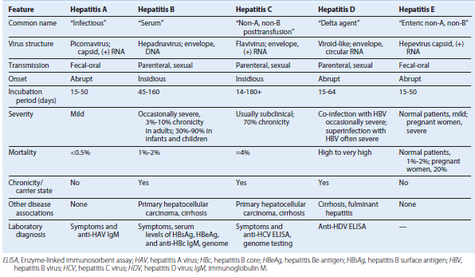

Characteristics of Hepatitis A Virus

Stable to:
Acid at pH 1
Solvents (ether, chloroform)
Detergents
Salt water, groundwater (months)
Drying (stable)

Temperature:
4° C for weeks: stable
56° C for 30 minutes: stable
61° C for 20 minutes: partial inactivation

Inactivated by:
Chlorine treatment of drinking water
Formalin (0.35%, 37° C, 72 hours)
Peracetic acid (2%, 4 hours)
β-Propiolactone (0.25%, 1 hour)
Ultraviolet radiation (2 μW/cm2/min)

Picornavirus structure of hepatitis A virus. The icosahedral capsid is made up of four viral polypeptides (VP1 to VP4). Inside the capsid is a single-stranded positive-sense ribonucleic acid (ssRNA) that has a genomic viral protein (VPg) on the 5′ end.

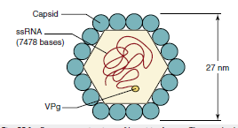

Spread of hepatitis A virus within the body.
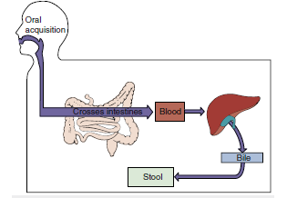

Epidemiology of Hepatitis A Virus and Hepatitis E Virus
Disease/Viral Factors
Capsid viruses are strongly resistant to inactivation.
Contagious period extends from before to after symptoms.
Virus may cause asymptomatic shedding.
Transmission
Virus can be transmitted via fecal-oral route.
Ingestion of contaminated food and water can cause infection.
HAV in shellfish is from sewage-contaminated water.
HEV from pigs and game animals.
Virus can be transmitted by food handlers, day-care workers, and children.
Who Is at Risk?
People in overcrowded, unsanitary areas
Travelers to high-risk regions
Children: mild disease, possibly asymptomatic; day-care centers are a major source of spread of HAV
Adults: abrupt-onset hepatitis
Pregnant women: high mortality associated with HEV
Geography/Season
Virus is found worldwide.
There is no seasonal incidence.
Means of Control
Good hygiene.
HAV: passive antibody protection for contacts
Killed vaccine
Live vaccine in China

Unique Features of Hepadnaviruses
Virus has enveloped virion containing partially double-stranded, circular DNA genome.
Replication is through an overlapping circular RNA intermediate.
Virus encodes and carries a reverse transcriptase.
Virus encodes several proteins (HBsAg [L, M, S]; HBe/HBc antigens) that share genetic sequences but with different in-frame start codons.
HBV has a strict tissue tropism to the liver.
HBV-infected cells produce and release large amounts of HBsAg particles lacking DNA.
The HBV genome can integrate into the host chromosome.
HBc, Hepatitis B core antigen; HBe, hepatitis Be antigen; HBsAg, hepatitis B surface antigen; HBV, hepatitis B virus.

Hepatitis B virus (Dane particle) and hepatitis B surface antigen (HBsAg) particles. The spherical HBsAg consists mainly of the S form of HBsAg, with some M. The filamentous HBsAg has S, M, and L forms. bp, Base pair; DNA, deoxyribonucleic acid; L, gp42; M, gp36; S, gp27.
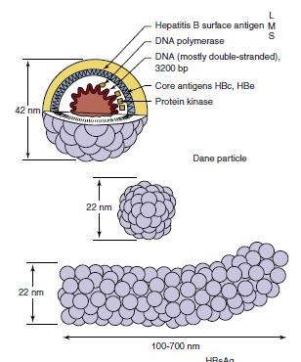

Replication of hepatitis B virus (HBV). After entry into the hepatocyte and uncoating of the nucleocapsid core, the partially double-stranded deoxyribonucleic acid (DNA) genome is delivered to the nucleus and completed. Transcription of the genome produces four messenger RNAs (mRNAs), including an mRNA larger than the genome (3500 bases). The mRNA then moves to the cytoplasm and is translated into protein. Core proteins assemble around the 3500-base mRNA, and negative-sense DNA is synthesized by a reverse transcriptase activity in the core. The ribonucleic acid (RNA) is then degraded while a positive sense (+) DNA is synthesized. The filled core associates with HBsAg containing endoplasmic reticulum membranes, is enveloped before completion of the positive-sense DNA, and is then released by exocytosis with HBsAg-containing particles. HBeAg, Hepatitis Be antigen; HBsAg, hepatitis B surface antigen.
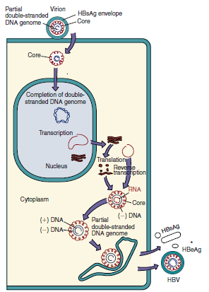

DNA, RNA, messenger RNA (mRNA), and proteins of hepatitis B virus. The inner green circles represent the DNA genome, with the nucleotide number at the center. DR1 and DR2 are direct repeat sequences of DNA and are important for replication and integration of the genome. The 3500-base transcript (outer black thin-line circle) is larger than the genome and is the template for replication of the genome. Bold arcs represent mRNA for viral proteins. Note that several proteins are translated from the same mRNA but from different AUG codons and that different mRNAs overlap. AAA, 3′ PolyA (polyadenylate) at end of mRNA; AUG, adenine, uracil, guanine; C, C mRNA for hepatitis B core antigen (HBcAg); HBsAg, hepatitis B surface antigen; l, large glycoprotein; m, medium glycoprotein; P, polymerase; s, small glycoprotein; S, mRNA for HBs antigen; X, X mRNA. (From Cohen, J., Powderly, W.G., Opal, S.M., 2010. Infectious Diseases, third ed. Mosby, Philadelphia, PA.)

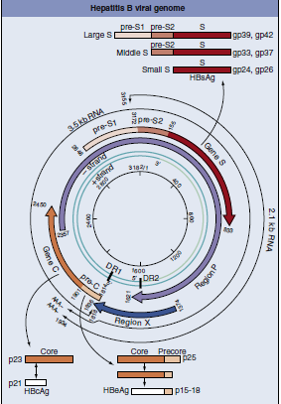

Major determinants of acute and chronic hepatitis B virus (HBV) infection. HBV infects the liver but does not cause direct cytopathology. Cell-mediated immune lysis of infected cells produces the symptoms and resolves the infection. Insufficient immunity can lead to chronic disease. Chronic HBV disease predisposes a person to more serious outcomes. Purple arrows indicate symptoms; green arrows indicate a possible outcome.
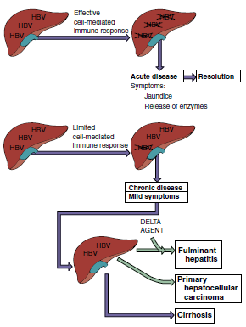

Spread of hepatitis B virus (HBV) in the body. Initial infection with HBV occurs through injection, unprotected sex, and birth. The virus then spreads to the liver, replicates, induces a viremia, and is transmitted in various body secretions in addition to blood to start the cycle again. Symptoms are caused by cell-mediated immunity (CMI) and immune complexes between antibody and hepatitis B surface antigen (HBsAg). IV, Intravenous.

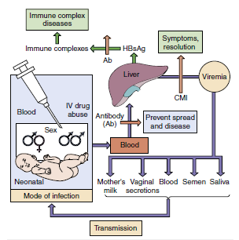

High-Risk Groups for Hepatitis B Virus Infection
People from endemic regions (i.e., China, parts of Africa, Alaska, Pacific Islands)
Babies of mothers with chronic hepatitis B virus
Intravenous drug abusers
People with multiple sex partners
Health care personnel who have contact with blood
Residents and staff members of institutions for the mentally retarded
Hemophiliacs and other patients requiring blood and blood product treatmentsa
Hemodialysis patients and blood and organ recipientsa
a Screening of blood, blood products, and transplantable organs have minimized risk.

Symptoms of typical acute viral hepatitis B infection are correlated with the four clinical periods of this disease. RUQ, Right upper quadrant. (Modified from Hoofnagle, J.H., 1983. Type A and type B hepatitis. Laboratory Medicine 14, 705–716.)

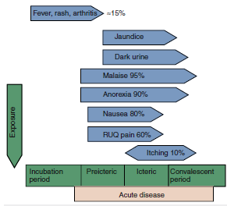

Clinical outcomes of acute hepatitis B infection. HBsAg, Hepatitis B surface antigen. (Modified from White, D.O., Fenner, F., 1986. Medical Virology, third ed. Academic, New York.)
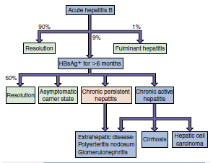

(A) Serologic events associated with the typical course of acute hepatitis B disease. (B) Development of the chronic hepatitis B virus carrier state. Routine serodiagnosis depends on detection of immunoglobulin M anti-HBc during the “hepatitis B surface antigen (HBsAg) window,” when HBs and anti-HBs are undetectable. Anti-HBc, Antibody to hepatitis B core antigen [HBcAg]; Anti-HBe, antibody to hepatitis Be antigen [HBeAg]; Anti-HBs, antibody to HBsAg. (Modified from Hoofnagle, J.H., 1981. Serologic markers of hepatitis B virus infection. Annual Review of Medicine 32, 1–11.)
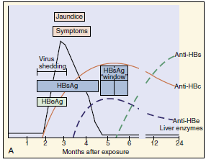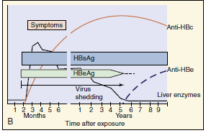

Interpretation of Serologic Markers of Hepatitis B Virus Infection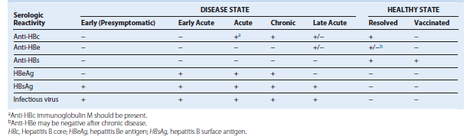

Outcomes of hepatitis C virus infection. Enzymes in green are targets for antiviral drugs.
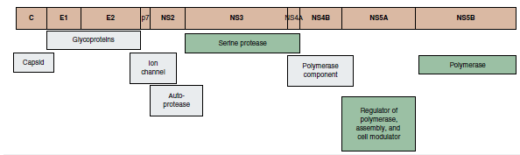

Epidemiology of Hepatitis B, C,and D Viruses
Disease/Viral Factors
Enveloped virus is labile to drying. HBV is less sensitive to detergents than other enveloped viruses.
Virus is shed during asymptomatic periods.
HBV (10%) and HCV (70%) cause chronic infection with potential virus shedding.
Transmission
In blood, semen, and vaginal secretions (HBV: saliva and mother’s milk)
Via transfusion, needlestick injury, shared drug paraphernalia, sexual intercourse, and breast-feeding.
Who Is at Risk?
Children: mild asymptomatic disease with establishment of chronic infection.
Adults: insidious onset of hepatitis.
HBV-infected people co-infected or superinfected with HDV: abrupt, more severe symptoms with possible fulminant disease.
Adults with chronic HBV or HCV: at high risk for cirrhosis and primary hepatocellular carcinoma.
Geography/Season
Viruses are found worldwide.
There is no seasonal incidence.
Modes of Control
Avoidance of high-risk behavior.
HBV: virus-like particle (HBsAg) vaccines.
HBV and HCV screening of blood supply.
HBV, Hepatitis B virus; HCV, hepatitis C virus; HDV, hepatitis D virus.

Hepatitis C proteins and their function. Highlighted proteins are targets for antiviral drugs. (Adapted from Scheel, T.K.H., Rice,C.M., 2013. Understanding the hepatitis C virus life cycle paves the way for highly effective therapies. Nature Medicine 19 [7], 837–849.)
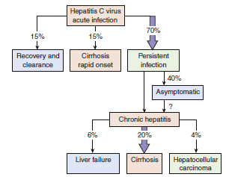

Hepatitis C Antiviral Drugs and Combinations
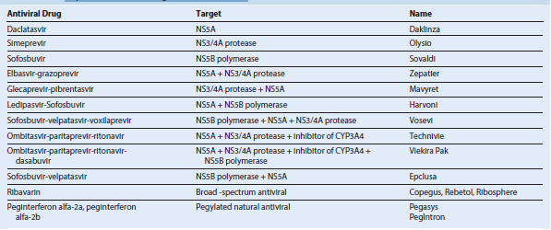

Consequences of delta virus infection. Delta virus (δ) requires the presence of hepatitis B virus (HBV) infection. Superinfection of a person already infected with HBV (carrier) causes more rapid, severe progression than co-infection (shorter arrow).
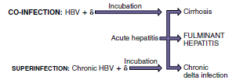

Delta hepatitis virion. HBsAg, Hepatitis B surface antigen; ssRNA, single-stranded RNA.
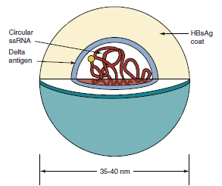

Clinical Summaries
Hepatitis A: A 37-year-old man develops fever, chills, headache, and fatigue 4 weeks after eating at a greasy-spoon diner. Within 2 days, he develops anorexia, vomiting, and right upper quadrant abdominal pain followed by jaundice, dark-colored urine, and pale stools persisting for 12 days. Then symptoms decrease.
Hepatitis B: A 27-year-old IV drug user develops symptoms of hepatitis 60 days after using a dirty needle.
Hepatitis B and D: A different IV drug user develops symptoms of hepatitis, altered mental capacity, and massive hepatic necrosis and then dies.
Hepatitis C: Elevated liver enzymes were detected in an individual during a physical examination. Hepatitis C virus in the blood was detected by enzyme-linked immunosorbent assay. Ten years later, cirrhosis and liver failure developed, requiring a liver transplant.

